**Attribute Playbook 9/12 – Shane Irons**

**#1. Create temp table to prepare for additional parametric sql queries. This takes about 30-45 minutes to run the first step.**

**create table PIM_STAGE.TEMP_VOLTAGE NOLOGGING as**

**select ar."ID" as ID,**

**ar."Identifier" as PART_ID --ItemNo/VariantNo/ProductNo**

**, attrlang."Name" as ATTRIBUTE_NM**

**, attrval."Value" as ATTRIBUTE_VALUE_TX**

**, ul."Symbol" as ATTRIBUTE_UOM_CD**

**, ul."Name" as ATTRIBUTE_UOM_NM**

**,DECODE( "EntityID", 1000, 'Items',1100, 'Products', 1200, 'Variants') as ARTICLE_TYPE_CD**

**,DECODE( ad."Res_Int_01", 1, 'Supplier Item', 2, 'ERP Item', 3, 'URL Asset') as ITEM_TYPE_CD**

**, ad."Res_Int_01" as PART_NO**

**from hpm_master."ArticleRevision" ar**

**,hpm_master."ArticleAttribute" attr**

**,hpm_master."ArticleDetail" ad**

**,hpm_master."ArticleAttributeLang" attrlang**

**,hpm_master."ArticleAttributeValue" attrval**

**,HPM_MAIN."UnitLang" ul**

**where ar."ID" = attr."ArticleRevisionID"**

**and ar.ID = ad."ArticleRevisionID"**

**--and ar."Identifier" = '101005128'**

**and attr.ID = attrlang."ArticleAttributeID"**

**and attrlang."Name" = 'Voltage' --Put the Attribute Name here**

**and attrlang."ArticleAttributeID" = attrval."ArticleAttributeID"**

**and attrval."LanguageID" = 9 --English (Everything is English for the moment)**

**and attr."UnitID" = ul."UnitID"**

**and ul."LanguageID" = 9**

**;**

**#2. Run a query to look at all valid UOMs and counts**

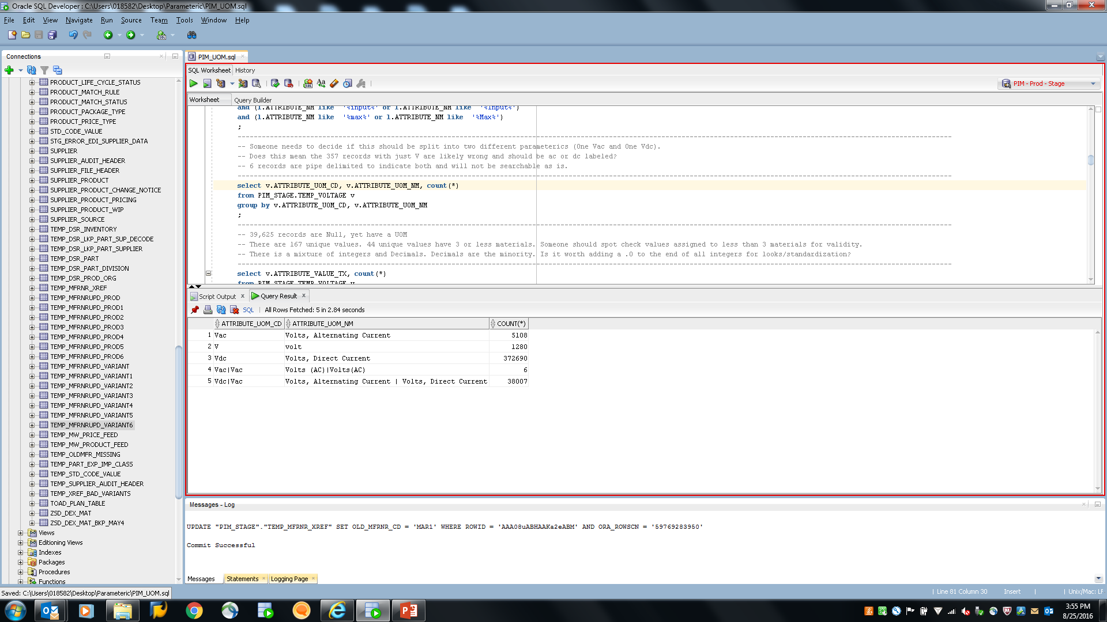

SQL:

select v.ATTRIBUTE_UOM_CD, count(*)

from PIM_STAGE.TEMP_VOLTAGE v

group by v.ATTRIBUTE_UOM_CD

;

**2b. Get list of materials with Bad UOMs**

select ar."ID" as VARIANT_AR_ID,

v.PART_ID as VARIANT_NO, v.ATTRIBUTE_VALUE_TX, v.ATTRIBUTE_UOM_CD, sgl."Name" as StructureGroupName

, ad."Res_Text100_01" as MFR_PART_NO--, ar2."ID" as VAIANT_AR_ID, ar2."Identifier" as VARIANT_NO, ar2."EntityID" as ENTITY_ID

, ad."Res_Text2G_02" as DATASHEET_URL

from PIM_STAGE.TEMP_CAPACITANCE v,

hpm_master."ArticleStructureMap" asm,

HPM_MAIN."StructureGroupRevision" sgr,

HPM_MAIN."StructureGroupLang" sgl,

hpm_master."ArticleRevision" ar -- Variant

,hpm_master."ArticleRevision" ar2

,hpm_master."ArticleDetail" ad -- Manufacturer

where v.ATTRIBUTE_UOM_CD in ('nF','uF/pF')

and v.ID = ar."ID"(+)

and v.ID = asm."ArticleRevisionID"(+)

and asm."StructureGroupID" = sgr."StructureGroupID"(+)

and sgr.ID = sgl."StructureGroupRevisionID"(+) and sgl."LanguageID"(+) = 9

and ar."ID"= ar2."ID"(+)

and ar2."ID" = ad."ArticleRevisionID"(+)

and ar2."EntityID"(+) = 1200;

**#3. Sql for UOM by Taxonomy with counts**

select sgl."Name" as StructureGroupName, v.ATTRIBUTE_UOM_CD, count(*)

from PIM_STAGE.TEMP_VOLTAGE v,

hpm_master."ArticleStructureMap" asm,

HPM_MAIN."StructureGroupRevision" sgr,

HPM_MAIN."StructureGroupLang" sgl,

hpm_master."ArticleRevision" ar -- Variant

,hpm_master."ArticleRevision" ar2

,hpm_master."ArticleDetail" ad -- Manufacturer

where v.ID = ar."ID"(+)

and v.ID = asm."ArticleRevisionID"(+)

and asm."StructureGroupID" = sgr."StructureGroupID"(+)

and sgr.ID = sgl."StructureGroupRevisionID"(+) and sgl."LanguageID"(+) = 9

and ar."ID"= ar2."ID"(+)

and ar2."ID" = ad."ArticleRevisionID"(+)

and ar2."EntityID"(+) = 1200

group by sgl."Name", v.ATTRIBUTE_UOM_CD

order by sgl."Name", v.ATTRIBUTE_UOM_CD

;

**#4. Check for un-allowed characters:**

select ar."ID" as VARIANT_AR_ID,

v.PART_ID as VARIANT_NO, v.ATTRIBUTE_VALUE_TX, v.ATTRIBUTE_UOM_CD, sgl."Name" as StructureGroupName

, ad."Res_Text100_01" as MFR_PART_NO--, ar2."ID" as VAIANT_AR_ID, ar2."Identifier" as VARIANT_NO, ar2."EntityID" as ENTITY_ID

, ad."Res_Text2G_02" as DATASHEET_URL

from PIM_STAGE.TEMP_VOLTAGE v,

hpm_master."ArticleStructureMap" asm,

HPM_MAIN."StructureGroupRevision" sgr,

HPM_MAIN."StructureGroupLang" sgl,

hpm_master."ArticleRevision" ar -- Variant

,hpm_master."ArticleRevision" ar2

,hpm_master."ArticleDetail" ad -- Manufacturer

where REGEXP_LIKE(v.ATTRIBUTE_VALUE_TX, '[^0-9|.]+')

and v.ID = ar."ID"(+)

and v.ID = asm."ArticleRevisionID"(+)

and asm."StructureGroupID" = sgr."StructureGroupID"(+)

and sgr.ID = sgl."StructureGroupRevisionID"(+) and sgl."LanguageID"(+) = 9

and ar."ID"= ar2."ID"(+)

and ar2."ID" = ad."ArticleRevisionID"(+)

and ar2."EntityID"(+) = 1200;

**#5. Check for Null Values**

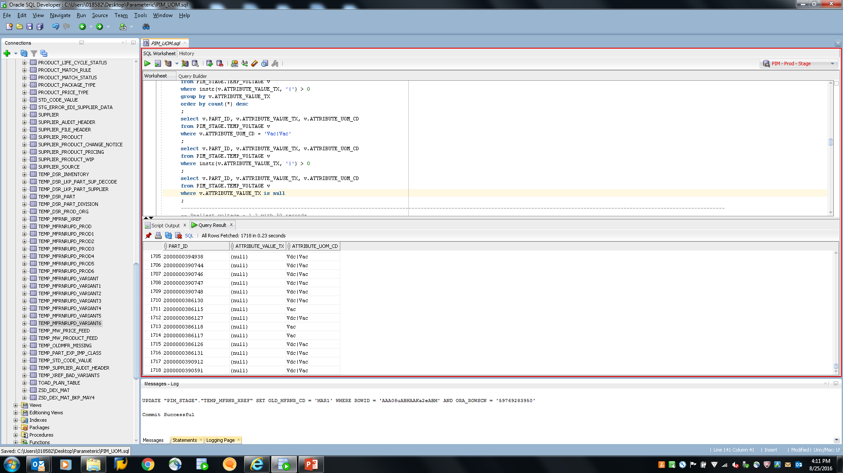

SQL:

select ar."ID" as VARIANT_AR_ID,

v.PART_ID as VARIANT_NO, v.ATTRIBUTE_VALUE_TX, v.ATTRIBUTE_UOM_CD, sgl."Name" as StructureGroupName

, ad."Res_Text100_01" as MFR_PART_NO--, ar2."ID" as VAIANT_AR_ID, ar2."Identifier" as VARIANT_NO, ar2."EntityID" as ENTITY_ID

, ad."Res_Text2G_02" as DATASHEET_URL

from PIM_STAGE.TEMP_VOLTAGE v,

hpm_master."ArticleStructureMap" asm,

HPM_MAIN."StructureGroupRevision" sgr,

HPM_MAIN."StructureGroupLang" sgl,

hpm_master."ArticleRevision" ar -- Variant

,hpm_master."ArticleRevision" ar2

,hpm_master."ArticleDetail" ad -- Manufacturer

where v.ATTRIBUTE_VALUE_TX is null

and v.ID = ar."ID"(+)

and v.ID = asm."ArticleRevisionID"(+)

and asm."StructureGroupID" = sgr."StructureGroupID"(+)

and sgr.ID = sgl."StructureGroupRevisionID"(+) and sgl."LanguageID"(+) = 9

and ar."ID"= ar2."ID"(+)

and ar2."ID" = ad."ArticleRevisionID"(+)

and ar2."EntityID"(+) = 1200

;

**#6. Check for attributes with a | that do not have a matching UOM:**

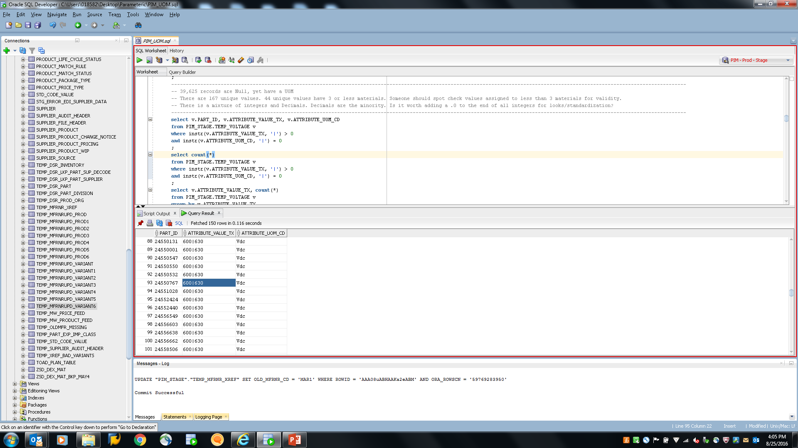

SQL:

select ar."ID" as VARIANT_AR_ID,

v.PART_ID as VARIANT_NO, v.ATTRIBUTE_VALUE_TX, v.ATTRIBUTE_UOM_CD, sgl."Name" as StructureGroupName

, ad."Res_Text100_01" as MFR_PART_NO--, ar2."ID" as VAIANT_AR_ID, ar2."Identifier" as VARIANT_NO, ar2."EntityID" as ENTITY_ID

, ad."Res_Text2G_02" as DATASHEET_URL

from PIM_STAGE.TEMP_VOLTAGE v,

hpm_master."ArticleStructureMap" asm,

HPM_MAIN."StructureGroupRevision" sgr,

HPM_MAIN."StructureGroupLang" sgl,

hpm_master."ArticleRevision" ar -- Variant

,hpm_master."ArticleRevision" ar2

,hpm_master."ArticleDetail" ad -- Manufacturer

where instr(v.ATTRIBUTE_VALUE_TX, '|') > 0

and instr(v.ATTRIBUTE_UOM_CD, '|') = 0

and instr(v.ATTRIBUTE_UOM_CD, '/') = 0

and v.ID = ar."ID"(+)

and v.ID = asm."ArticleRevisionID"(+)

and asm."StructureGroupID" = sgr."StructureGroupID"(+)

and sgr.ID = sgl."StructureGroupRevisionID"(+) and sgl."LanguageID"(+) = 9

and ar."ID"= ar2."ID"(+)

and ar2."ID" = ad."ArticleRevisionID"(+)

and ar2."EntityID"(+) = 1200;

**#7. Look at UOM Distribution:**

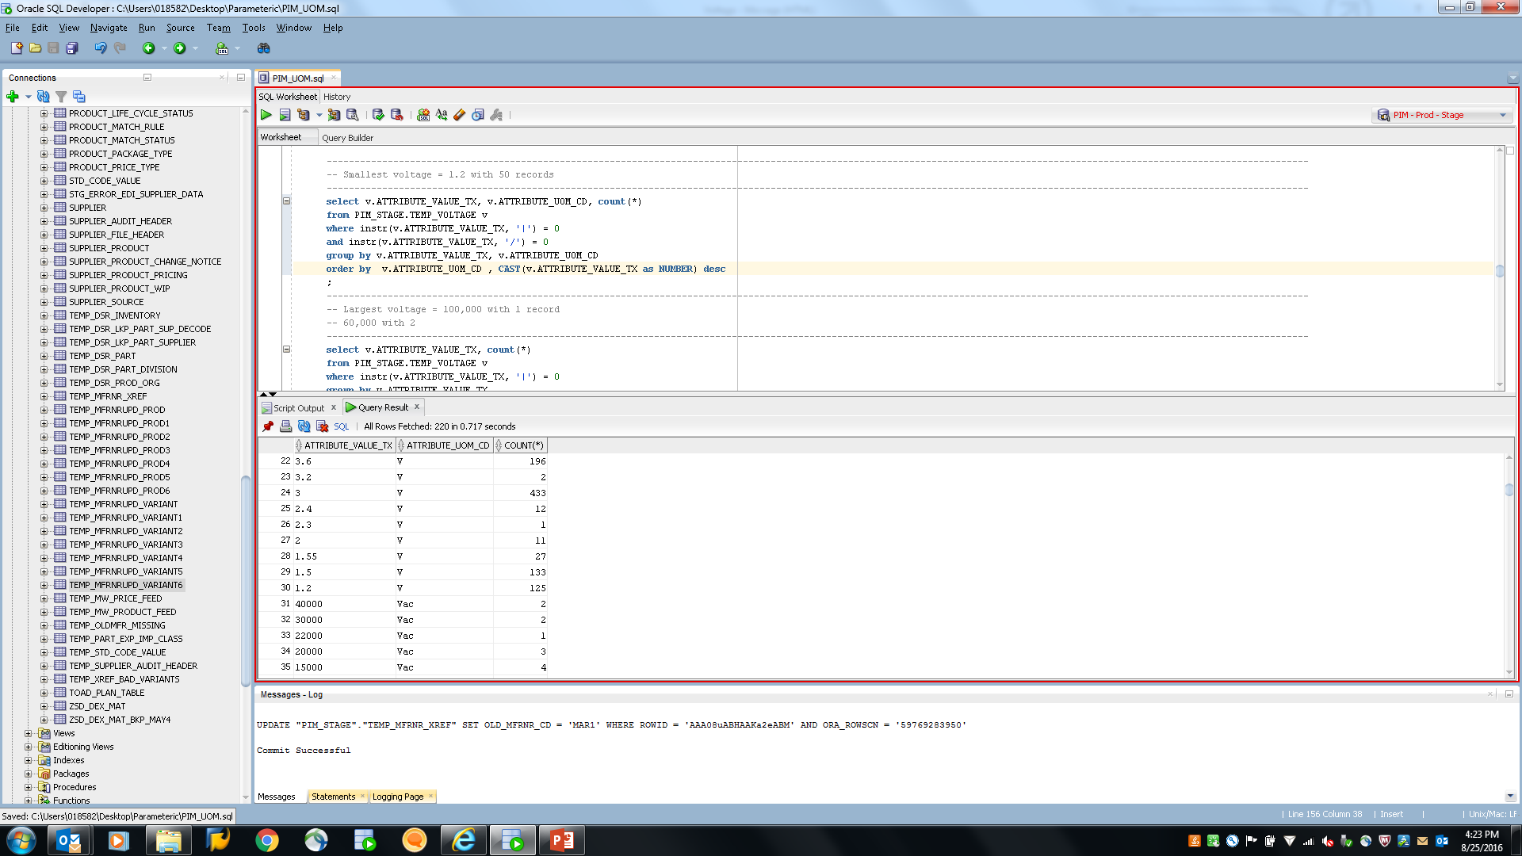

SQL:

select v.ATTRIBUTE_VALUE_TX, v.ATTRIBUTE_UOM_CD, count(*)

from PIM_STAGE.TEMP_VOLTAGE v

where instr(v.ATTRIBUTE_VALUE_TX, '|') = 0

and instr(v.ATTRIBUTE_VALUE_TX, '/') = 0

group by v.ATTRIBUTE_VALUE_TX, v.ATTRIBUTE_UOM_CD

order by v.ATTRIBUTE_UOM_CD , CAST(v.ATTRIBUTE_VALUE_TX as NUMBER) desc

;

**#8. Look at decimal places compared to the majority:**

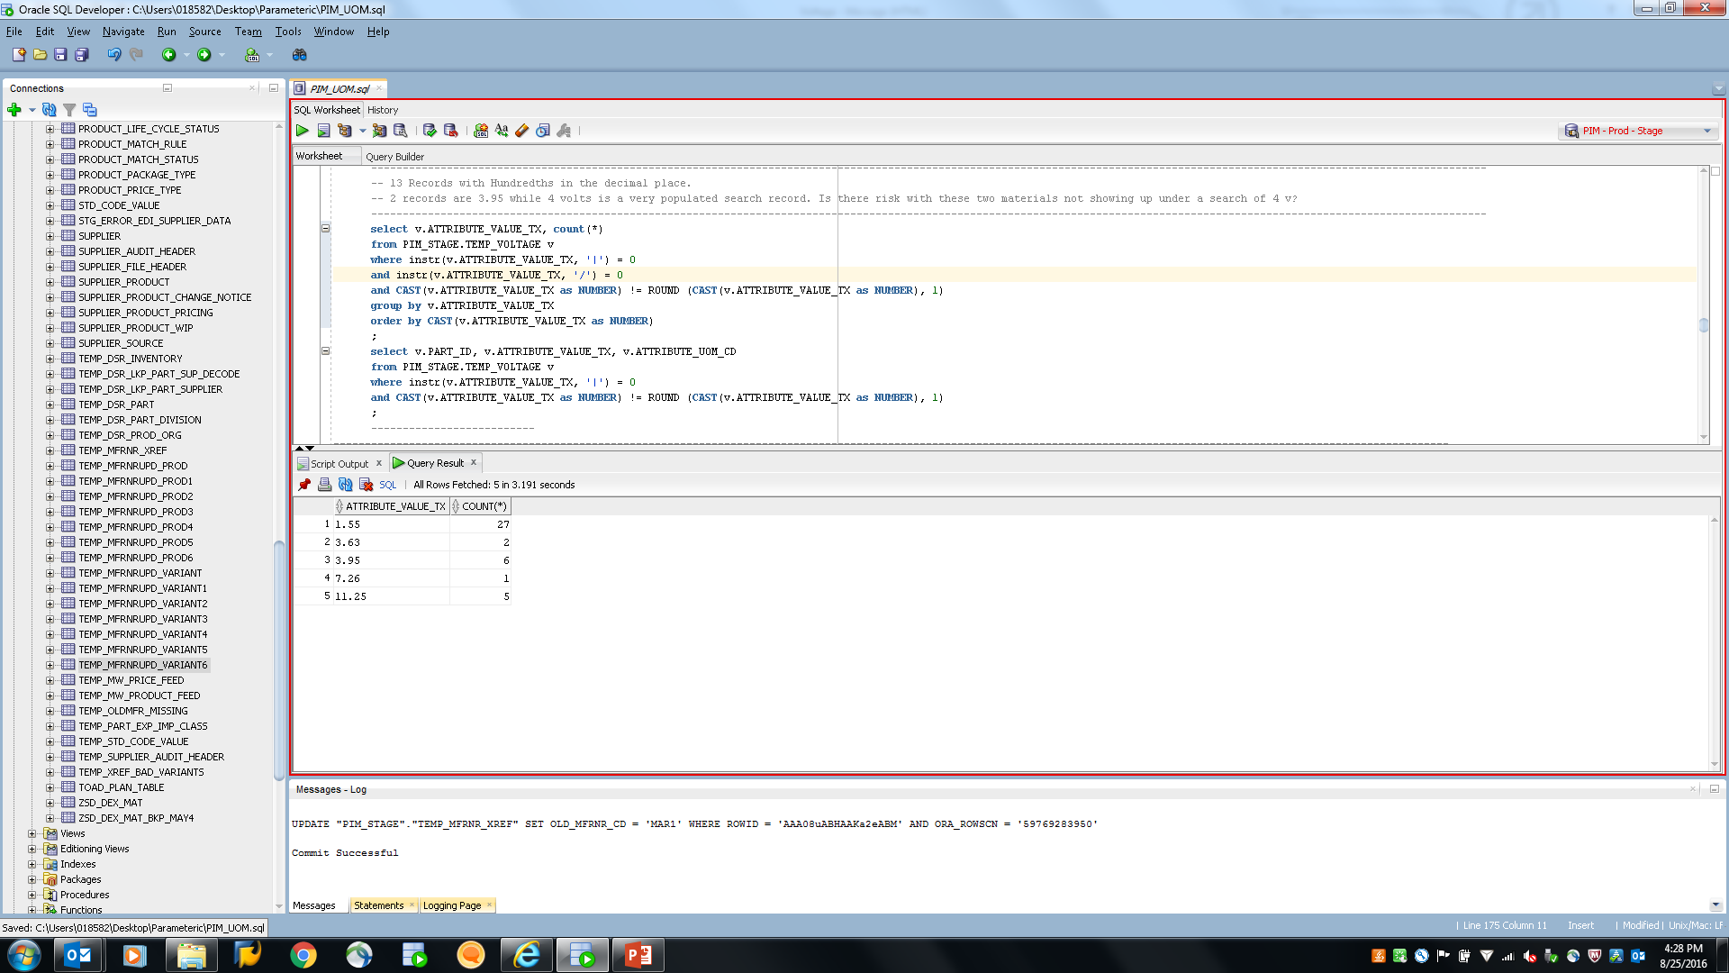

SQL:

select v.ATTRIBUTE_VALUE_TX, count(*)

from PIM_STAGE.TEMP_VOLTAGE v

where instr(v.ATTRIBUTE_VALUE_TX, '|') = 0

and instr(v.ATTRIBUTE_VALUE_TX, '/') = 0

and CAST(v.ATTRIBUTE_VALUE_TX as NUMBER) != ROUND (CAST(v.ATTRIBUTE_VALUE_TX as NUMBER), 1)

group by v.ATTRIBUTE_VALUE_TX

order by CAST(v.ATTRIBUTE_VALUE_TX as NUMBER) ;